**WEKA RESULTS**

**RandomForest Classifier:**

This was the best model with an accuracy of 97.15% and Kappa statistic was 0.7859, indicating a very strong agreement between predicted and observed response. It had better performance for the class 0 (0.77) (non Diabetic) than for the class 1 (Diabetic), with only 67.3% of recall. On the whole, as a model the latter was successful in the classification performance.

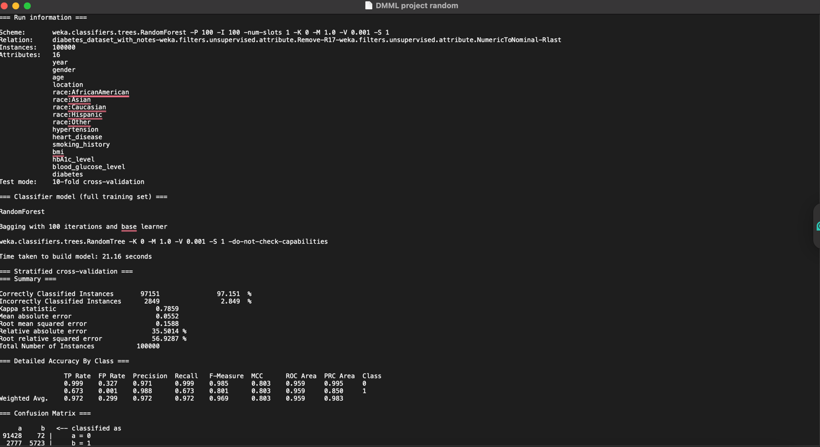

**Logistic Regression:**

Logistic regression model achieved an accuracy of 96.04% with a Kappa statistic of 0.7089 in affirming model performance. The output consists of coefficients for features within the dataset, then we can know how each feature (age, blood glucose levels, BMI, …) affects the chances of receiving diabetes diagnosis. The odds ratios show that age and blood glucose are the only significant predictors of diabetes.

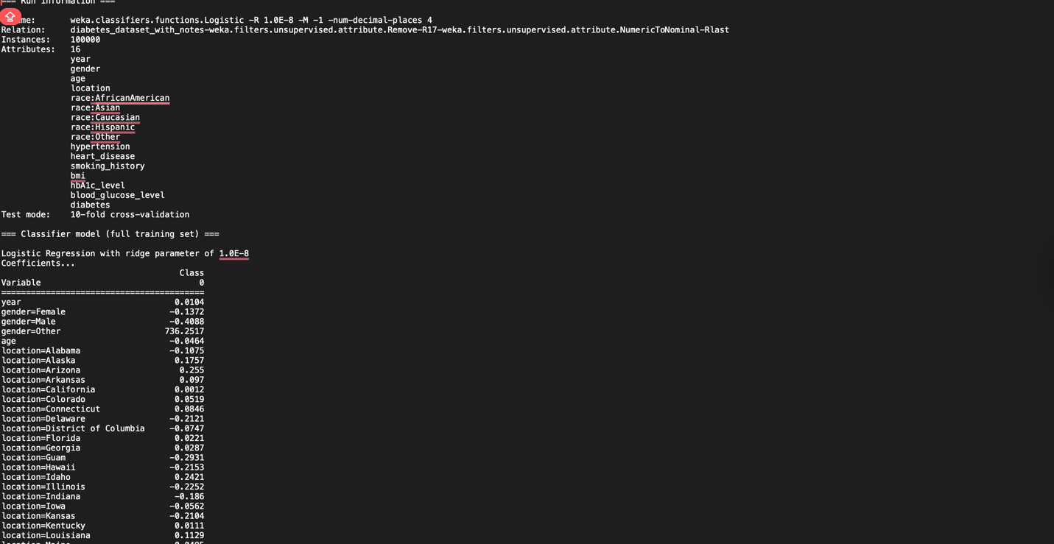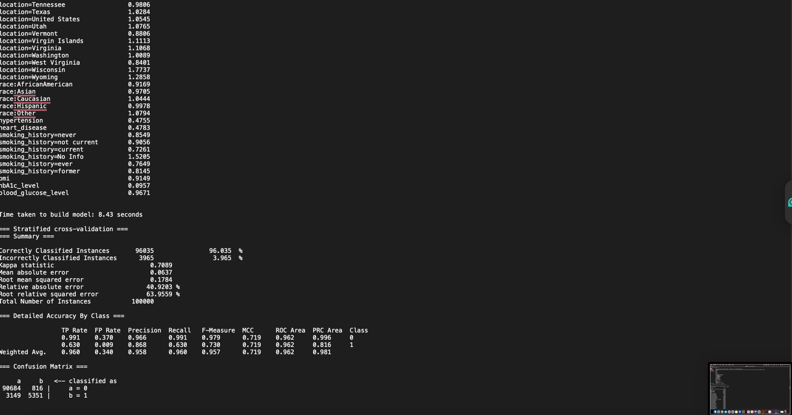

**J48 Decision Tree:**

The J48 decision tree classifier achieved accuracy of 96.05% with Kappa statistic 0.7089 like logistic regression model. The classification is about splitting the data based on the most informative features, such as blood glucose and HbA1c levels to predict the diabetes status. It is also straightforward to interpret, which allows us to obtain insights that can make us understand about how the various features are associated with the prediction of diabetes.

